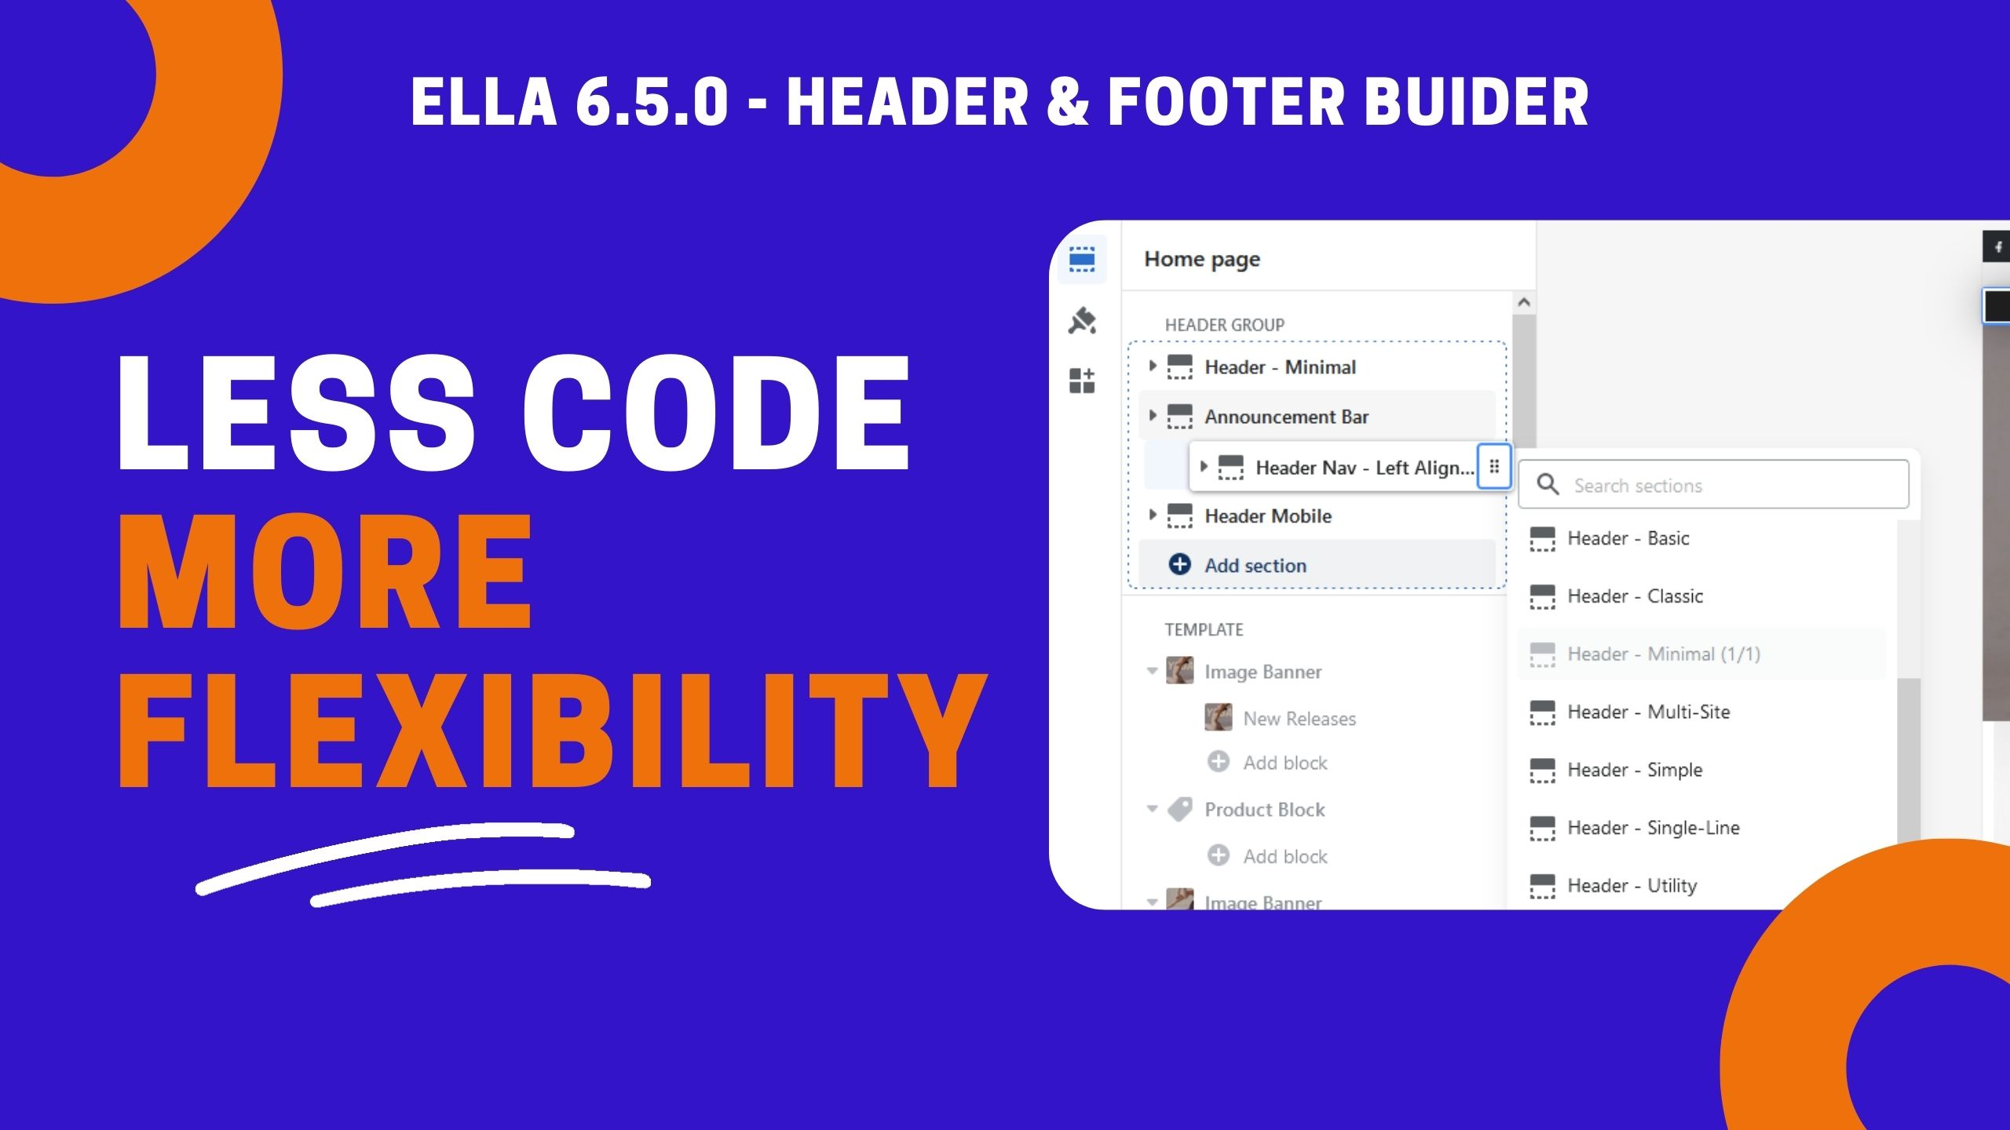

From Version 6.5.0, Ella supports new theme structure: Section Groups which allows you to customize Header and Footer flexibly without coding.

Instead of depending on our premade headers + footers, you now can add sections, change the position and arrange the header + footer layout you want.

More information for your imagination in this video: <https://youtu.be/JY7GyrXlLZo>

►► Instruction to set up Header: <https://halosoft.gitbook.io/ella-documentation/header/header-for-desktop>

►► Instruction to set up Footer: <https://halosoft.gitbook.io/ella-documentation/footer/footer-layout>

In Version 6.5.0, Ella also includes new update for Custom CSS from Shopify. Instead of using our theme built-in custom css, you now can use Custom Css for each section or for whole theme

►► Instruction to set up Custom Css: <https://halosoft.gitbook.io/ella-documentation/theme-settings/custom-css>

************

**Apply Header and Footer you want:**

Ella offers Multiple Layouts, so to apply the Header, Footer you want, you can copy our available data or you can add sections for Header, Footer easily as our above instruction.

**Update Theme:**

If you are using Ella from version 6.0.0 to 6.4.2, to update to Ella 6.5.0 it requires more steps to keep your settings:

- Copy data in this file: **index.json** from the old theme source to paste into the new theme source.

- Copy data in this file: **setting_data.json** from the old theme source to paste into the new theme source.

When you do these 2 steps, it can appear the errors, contact us at <https://halosoft.ticksy.com/> to receive the fix by support team or follow our Youtube video: https://halosoft.ticksy.com/